**DAILY ONLINE ACTIVITIES SUMMARY**

|  |  |  |  |  |  |  |  |  |
| --- | --- | --- | --- | --- | --- | --- | --- | --- |
| **Date:** | **19/05/2020** | | | | | **Name:** | **PRANEETA P HANDRAL** | |
| **Sem & Sec** | **4​th​ SEM. & ‘B’ SEC.** | | | | | **USN:** | **4AL19CS401** | |
| **Online Test Summary** | | | | | | | | |
| **Subject** | | **DESIGN ANALYSIS OF ALGORITHMS** | | | | | | |
| **Max. Marks** | | **30** | | **Score** | | | **14** | |
| **Certification Course Summary** | | | | | | | | |
| **Course** | **PYTHON FOR MACHINE LEARNING** | | | | | | | |
| **Certificate Provider** | | | **Greatlearning academy** | | **Duration** | | | **5 Hrs.** |
| **Coding Challenges** | | | | | | | | |
| **Problem Statement:** **A user will input two strings, and we find if one of the strings is a sub sequence of the other. Program prints “yes” if either the first string is a sub sequence of the second string or the second string is a sub sequence of the first string. Assume that, the length of the first string is smaller than or equal to the length of the second string.** | | | | | | | | |
| **Status:** **Executed.** | | | | | | | | |
| **Uploaded the report in Github** | | | | | **Yes** | | | |
| **If yes Repository name** | | | | | **LockdownCoding** | | | |
| **Uploaded the report in slack** | | | | | **Yes** | | | |

**Online Test Summary​:** 18CS42 test was scheduled from 9:15 am to 9:55 am and the test scores is 14 .The portion for the IA was 4 th module there were 25 questions and the time assigned was 40 minutes the questions were mcq type. But there was an issue with the time mentioned, so that we

got only 30mins. to finish the test. The time was not sufficient to answer all the questions. There were 20 questions of 1 mark and 5 questions of 2 marks respectively.

**Online Certification Course Summary​:** Today I’ve gone through with the steps and completed installation in my system. Anaconda is available free of coast and it is having two versions at present one is 2.7 and the other is 3.7. I have also downloaded the Anaconda 3.7 version on my PC. It is one of the platforms to Execute python programs and we will also find different IDE’s in Anaconda. In the Anaconda command prompt if we write conda list where conda is the basic keyword then we will get a list of items which are installed for python. It is shown in the below snapshot.

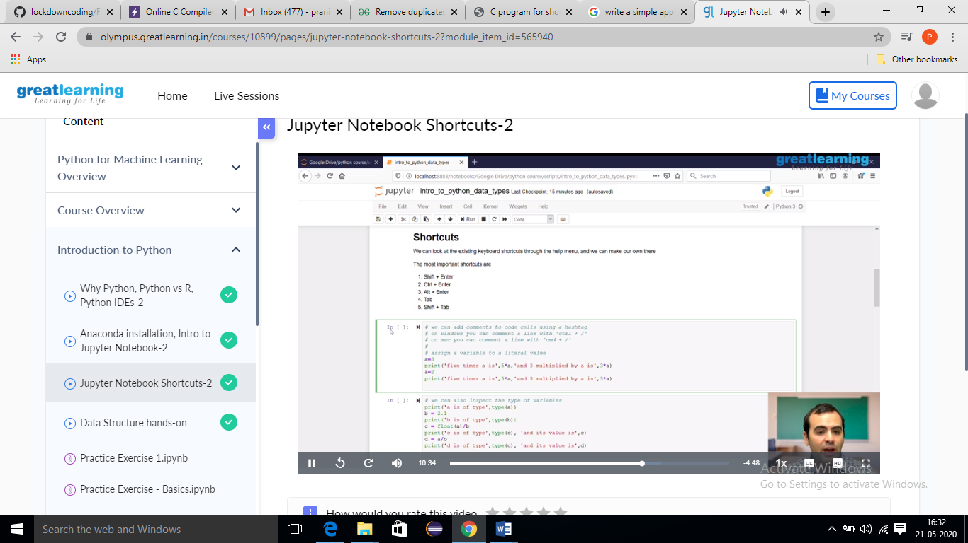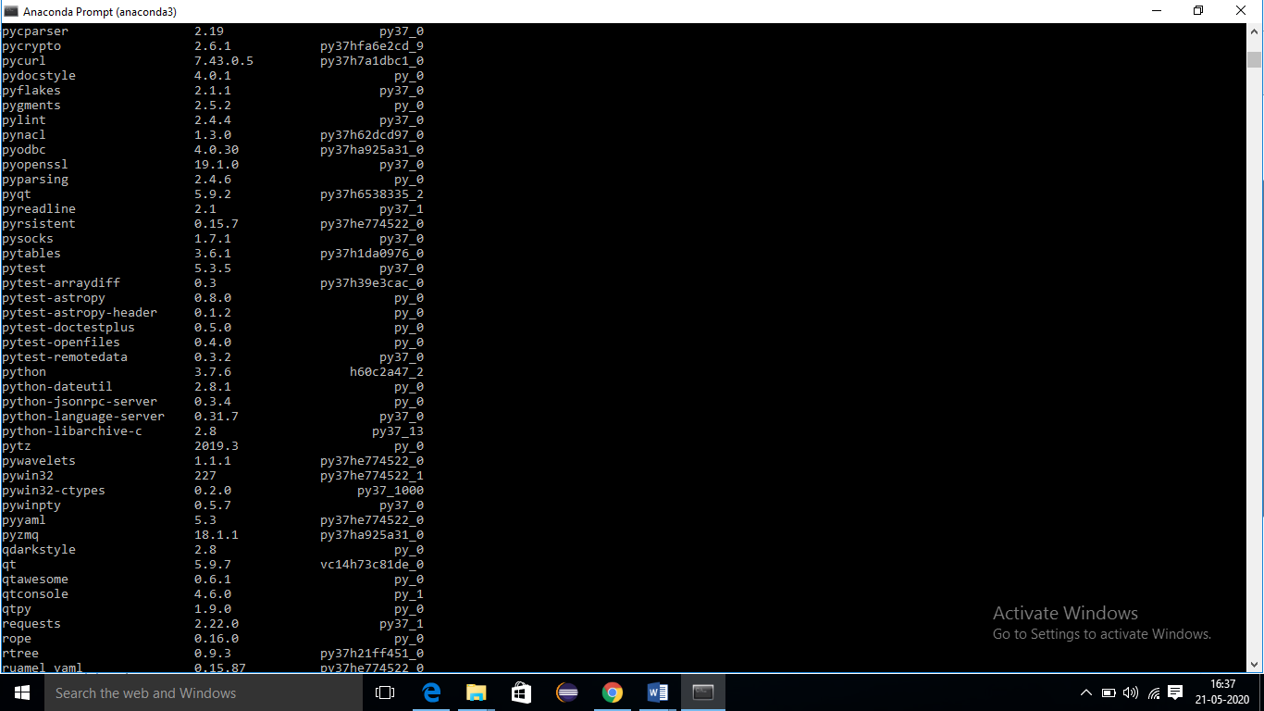

**Online coding Summary:** Today I received one program from Prof.Venkatesh CSE Dept. The program is mentioned above. to my GitHub repository and I’ve shared the snapshot below.

